Sneak peak the assessment for Level 2 programming (default options):

1. Budget Laptop Calculator GUI

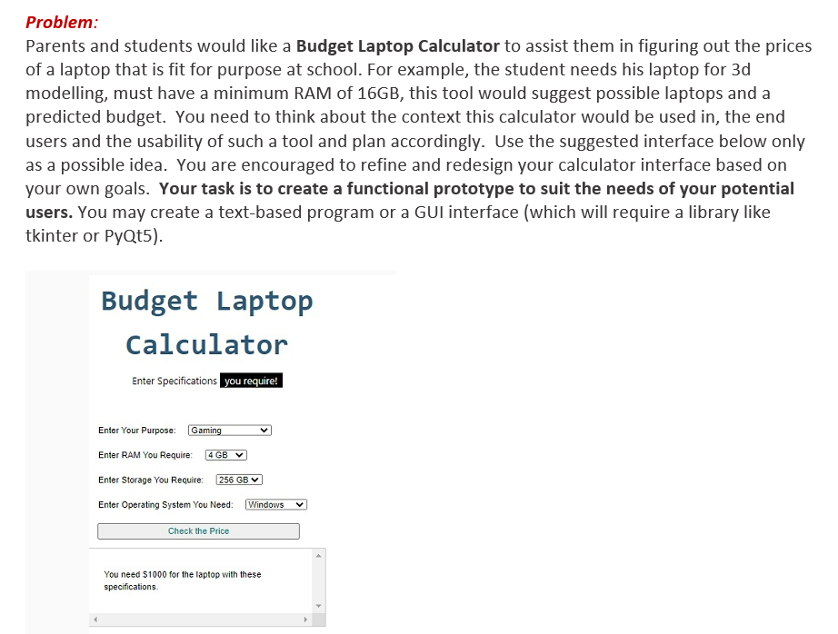

1. Program an interactive game of your choice

(you are encouraged to create your own world, however here is a potential idea:)

"Outsider's Odyssey - The Island": The player is an outsider who finds themselves stranded on a deserted island inhabited by a mysterious and isolated tribe. The tribe is distrustful of outsiders and has their own customs and traditions, making it difficult for the player to communicate and form relationships with them.

The player must learn to survive on the island, hunting and gathering for food and resources, while also avoiding dangerous predators and natural hazards. As the player explores the island, they will uncover clues and puzzles that reveal the tribe's history and secrets, ultimately leading to a confrontation with the tribe's leadership.

The player must navigate complex moral dilemmas and make difficult choices as they interact with the tribe, deciding whether to respect their customs or challenge them in order to achieve their objectives. The player's actions will have consequences, affecting the tribe's perception of them and ultimately determining their fate.

Additionally, the player must contend with the limited resources available on the island, managing their inventory and crafting tools and weapons in order to survive and progress. The player must also deal with the psychological toll of being stranded on a deserted island, facing challenges such as loneliness, fear, and despair.

Minimum requirements for a level 2 programming assessment:

* Evidence of using a collection (list, set, dictionary, tuple)
* Evidence of using functions with either parameters or return values
* Implementation of input/output/conditions/loops/2 types of data (numerical, text, boolean, etc.)
* Testing